13.1 Editors - Video Sequence Editor - Header
Video Sequence Editor - Header 1
Header right click menus 1
Editortype Menu 1

Video Sequence Editor - Header

The Header contains some menus and settings.

The header is divided into two areas. Left Type of sequencer view plus menus. Right settings.

Header right click menus

The general right click menu functionality is explained in chapter 6 Editors introduction.

Editortype Menu
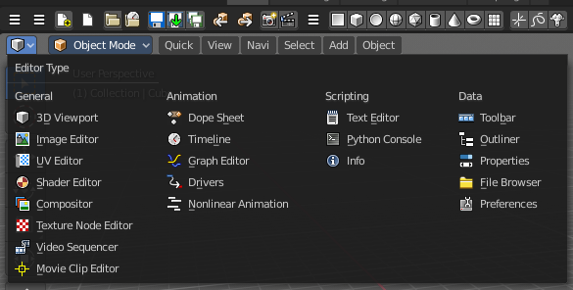
Bforartists is made of several editor types. Headers can display a menu where you can switch to other editor types.

This menu is hidden by default. It is meant to edit the layouts, and should not be necessary for regular work. You can reveal it in the header right click menu.

